NEXTrack Carrier Access
Introduction:
Dynamics TMS provides functionality and visibility by leveraging the Internet. NEXTrack is a combination of read only information or interactive functionality based on user roles. NEXTrack can be configured to provide carrier access to accept/reject loads, appointment scheduling, status update, freight bill entry.

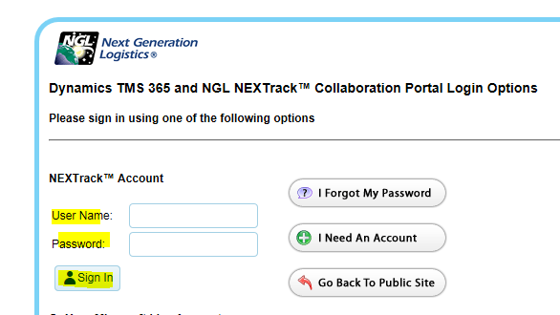
A BLUE question mark can be found on each page you are working on. Here users can store information and notes about how to use a page or insert instructions.

Click on the blue question mark, then click the pencil icon to edit. After entering in notes, be sure to click the save button. Entering notes by a specific user, will only be seen by that user.
The help screen will appear. Each user can add their own notes and procedures directly into this screen by clicking on the pencil icon to edit the help information. Click save when done. For example, if you click on the pencil icon, Peggy and can add her notes and procedures as reminders. Peggy will only see Peggy’s notes. All users will see ALL Help.
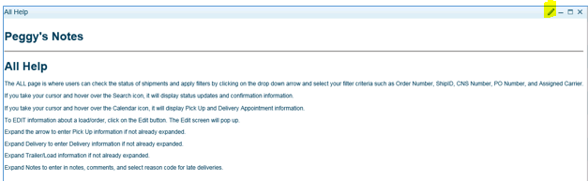
To change the column headers and select the data preferences to view, look for this icon to check on/off to display data. This is available anywhere you see this icon on a page.
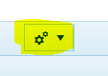

Home page
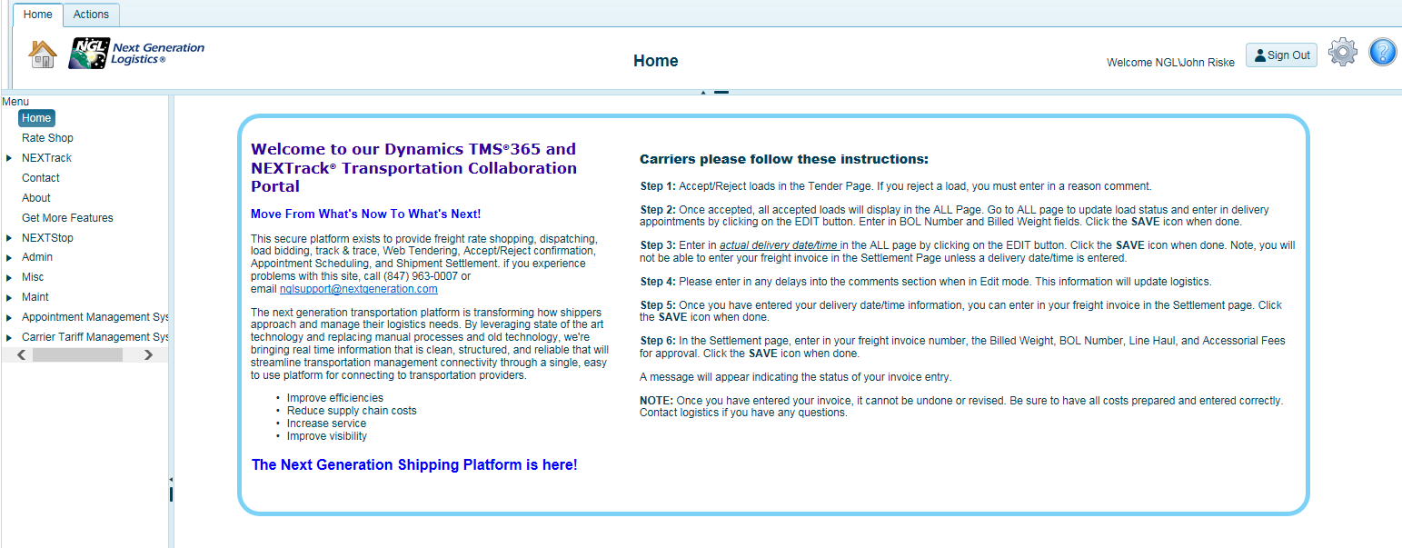
Click on the settings button to change password.

NEXTrack

Most user configurations will have access to NEXTrack and the pages contained within. By clicking the black arrow and expanding NEXTrack, you will see other pages accessible within NEXTrack.

Expand the black arrow next to NEXTrack to review the pages according to your credentials.
- NEXTrack
- ALL Used by carriers to enter appointments, load status, delivery confirmation, and search
capability.
- Tendered (Used for carrier dispatchers to accept/reject loads, depending on carrier user
credentials)
- Settlement (Used by carriers who will enter freight invoices, depending on carrier user
credentials)
- Settled Used by carriers to see approved invoices and payment status. Note, payment status
updates in the Settled page depends on shipper’s configuration and may not be used.
(Depending carrier user credentials)
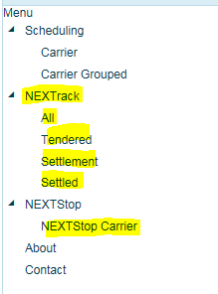

All Page
This is where carrier users can update the status of shipments and apply filters such as order number, ShipID, CNS Number, PO Number, and Assigned Carrier.
In most cases the CNS Number and the ShipID will be the same number. A ShipID will be assigned to every order. Multiple orders can be assigned to the same ShipID, for example, a multi stop load.
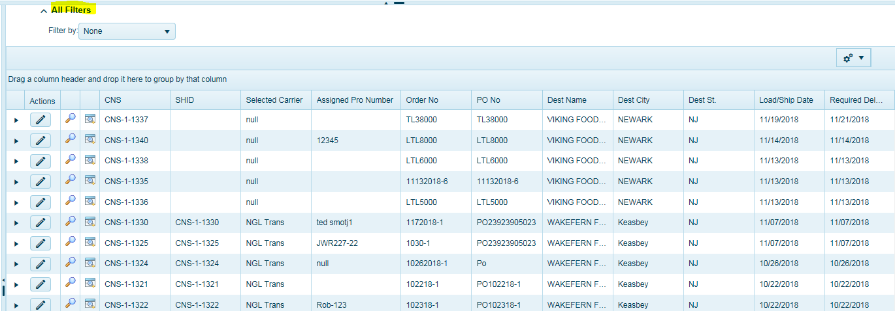
Users can apply filters to search for specific information. Use the drop-down list to apply filter criteria.
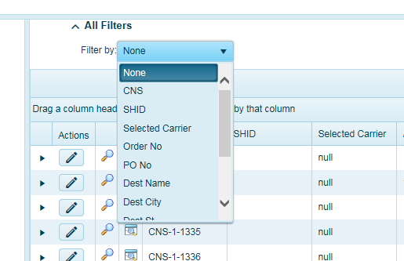

Hover your cursor over the magnifying glass to see all load status updates related to this order (load) whether the input is from EDI or carrier direct entry into the system.

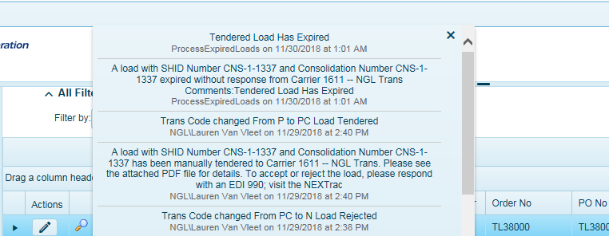

Hover your cursor over the Calendar icon to review appointment information.
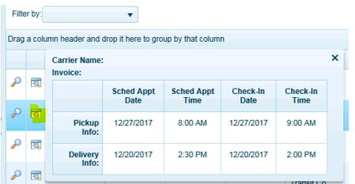
To see the items that are on this order, click on the black arrow to expand the page.
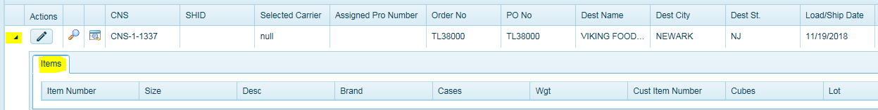
Click on the pencil icon to enter information such as Pick Up and Delivery appointment information, trailer number, seal number, load status comments, and more.
When shippers are using the scheduling system, these fields will auto populate. The appointment fields will be grayed out when the using the scheduling system and after an appointment is created. This is to protect the appointment for use within the scheduling system and that no one can edit the appointment when scheduling system is in use. Upon delivery, the fields will no longer be grayed out. Carriers should follow shippers’ requirements for data entry and what needs to be updated and when.

EDIT – Data Entry
To EDIT information about a load/order, provide status updates, click on the pencil icon.
The Edit screen will pop up. Be sure to click the save icon in the upper right-hand corner of the screen to save entries.
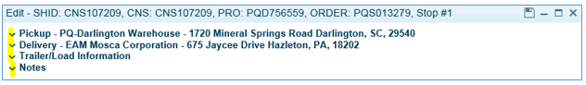
Expand the arrow to enter Pick Up information if not already expanded.
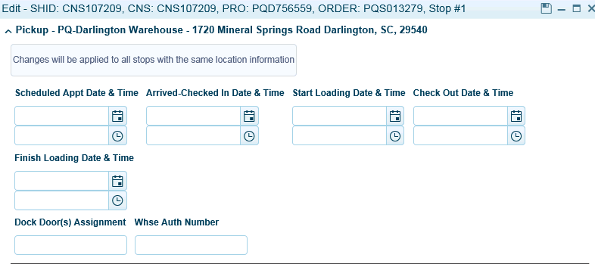
Expand Delivery to enter Delivery information if not already expanded.
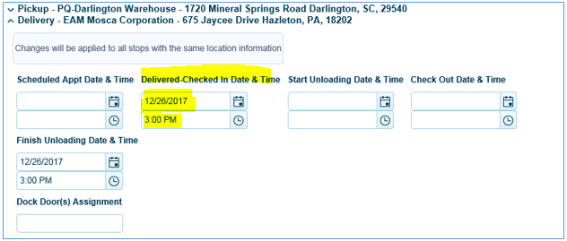
Carriers who will be using the Settlement page to enter freight invoices MUST enter in the Delivered Checked in Date & Time information highlighted in yellow above. Otherwise, the transaction will not be available for invoice entry in the Settlement page.

Expand Trailer/Load information if not already expanded.
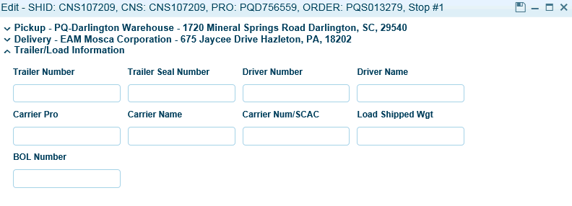
Expand Notes to enter in notes, comments, and select reason code for late deliveries.
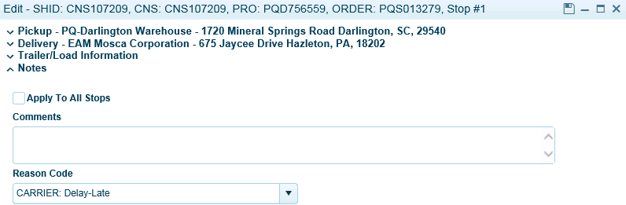

Tendered Page
This page will display all load tenders sent to each carrier by the logistics department. Carriers will only be able to see their own load tender information. Upon tendering by the logistics group, an email will be sent to the carrier indicating a load has been tendered to them and they should login and ACCEPT/REJECT the load. A PDF attachment should also be included with the email.
Once you’re logged in, go to the Tender page to review your tenders. Shippers may place a time constraint as to how long you have to accept/reject a load.

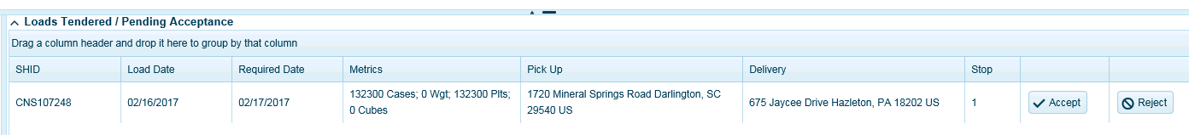
Carriers should accept/reject the load by clicking on the appropriate button.

If carrier Rejects a Load, they must enter a reason and click save.
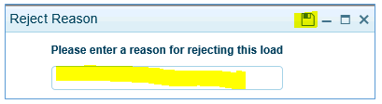
All accepted loads will disappear from the TENDER PAGE and now be available under the ALL PAGE for further updates and tracking.

Settlement Page
The Settlement page allows carriers or TMS users to enter in freight invoices. We have two options and users should seek instructions on which option is best to use based on your implementation.
1) Quick Edit – This is used for quick entry of the Freight Invoice Number and Total Invoice Amount.
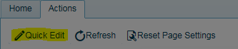
Click on the Quick Edit button in the Actions menu. A dialog box will open.
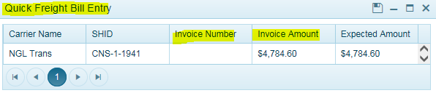

2) Detailed Freight Bill Entry-This is used to allow carriers/users to insert additional fees as part of their invoice. Click on the pencil icon to review and add fees.
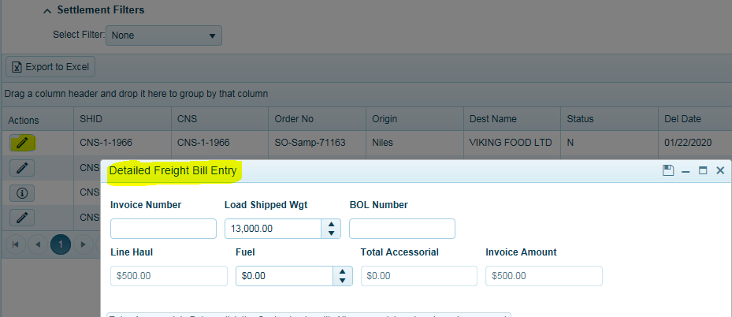
The settlement page is where carriers will enter in their freight invoices and fees. Again, depending on credentials, not all carrier users will have access to this page. Carrier users, who have been set up as accounting users, will have access to the Settlement and Settled Page for carriers.
In order for carriers to see data and enter their freight invoice within the Settlement Page, they will be required to enter in a delivery date/time stamp in the ALL Page. Only loads with a delivery date will appear in the Settlement Page.
Carriers must enter in their invoice for each load (CNS / ShipID). Summary invoices are not allowed. In situations where carriers have a summary invoice for more than 1 load, they must append a -1, -2 or –A, -B at the end of their invoice entry to make this freight invoice unique.

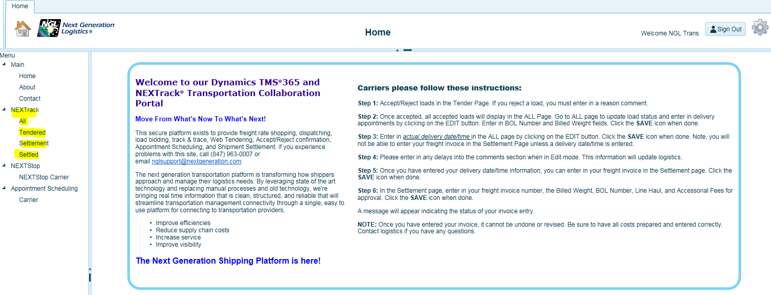

Click on Settlement to enter in your freight invoices. Must have entered in Delivery Date/Time in All Page first.
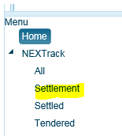

You can search for the CNS (aka ShipID) load you want to enter in your freight invoice for. Click on the pencil icon to EDIT.
N Status = Are new records waiting for freight bill entry.
PENDING Status = waiting on TMS user to approve entries.
FAILED Status = Are freight bills that have been entered but did not pass the audit function. This requires a TMS user to review this exception.
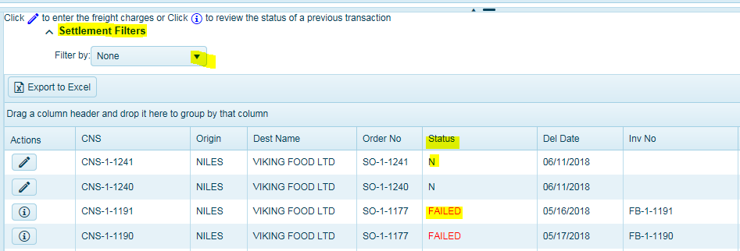
Click on the Pencil icon to enter Detailed Freight Invoice information.
The Detailed Freight Bill Entry Screen will open.
Click on the Information icon for to review the pending/failed freight bill entry. Note you will not be able to edit the freight bill after it has been entered and saved. If you made a mistake, carrier should contact the shipper.
Depending on system configuration and requirements, it is important to receive instructions from the shipper on expectations and requirements for entering freight bills.
Carriers must enter in their Invoice Number for this shipment. Once the invoice number has been entered, carriers can now enter in fees associated with an invoice if necesssary.
Click and expand the black arrow next to the CNS Number (ShipID) and click ADD FEE. Some configurations will already display the fee as part of the original freight cost calculation. There is no need to enter this fee again. If the fee is incorrect, carriers can edit the value by placing your cursor in the cost field and enter in new value. If no more fees, click save and the system will run the audit function.
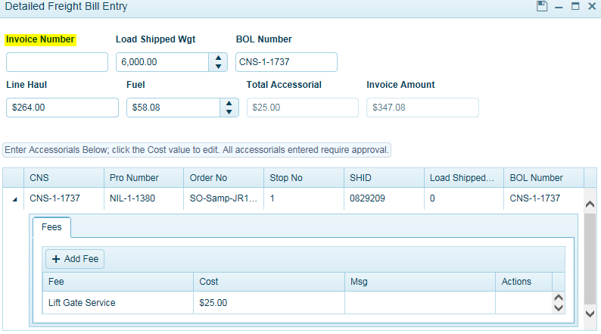
Too Add a fee:
Click Add Fee Select your appropriate fee that has been pre-configured from the drop-down list and fee amount. Click Add Fee again to add additional fees. If you do not see a fee that you’re trying to enter, contact the shipper prior to entering this invoice to have it added. At this time, you can close the page and re-enter invoice upon notice the fee has been updated. Do not click save until you have completed all entries.
When entering fees for the same stop, you only need to enter the fee one time on one of the stops.
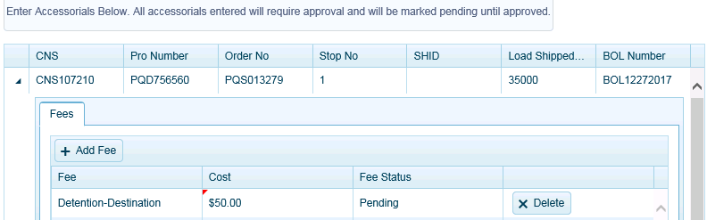
Click SAVE icon when done entering in fees. It is important to note that once fees have been entered and saved, the invoice process is complete, and carriers cannot change anything.
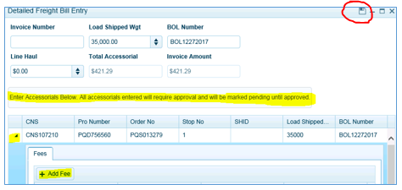

NEXTStop Carrier

This is the internal load posting or bidding solution. Carriers who are configured to gain access to shipper information may be granted access to the bid pages. Only carriers that have been granted access will be able to participate in reviewing and entering bids.
To bid on a load, click on the BID icon and a screen will pop open and allow you to submit your bid. Please enter any comments about this load.
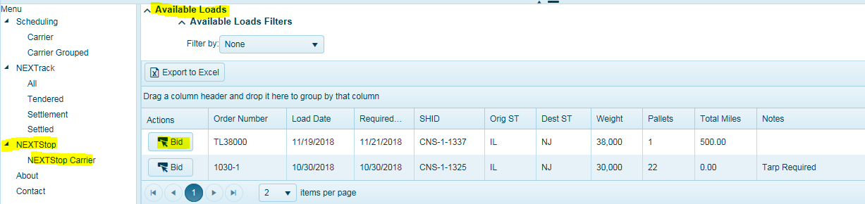
Once the bid is submitted, the TMS user will have knowledge that a bid has been submitted. TMS users will award the bids. If you have been awarded a bid, an email will be sent to the dispatcher email address set up by TMS user, requesting you to login and accept the load under the Tendered Page. A PDF attachment will also be included in the email
Most users will enter in an all-inclusive rate. Carrier bidders can add a comment for the shipper to see. Carriers should refer to shipper on requirements for bid entry.
IF NOT QUOTING FUEL, MUST ENTER ZERO COST AS A FLAT RATE.
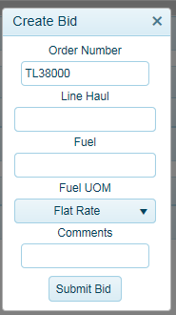
Click Submit Bid when done.
Bids placed will now be visible in the Pending Bids page. Carriers can withdraw their bid by clicking the Withdraw button.
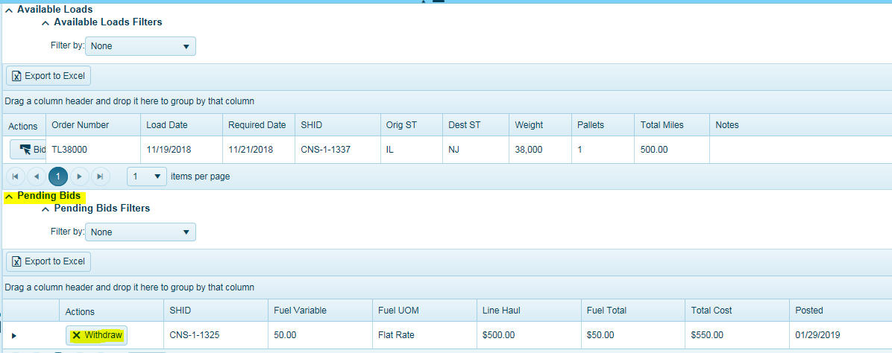
Once a user has awarded the carrier a bid, an email will be sent to the dispatch office notifying them a load has been tendered to them. Carriers will find this tender in the Tender Page and they must accept or reject the tender.

Finalized Bids (bids carrier has accepted) will be visible in this section for reference. The status code displays if the TMS user accepted or rejected the bid.
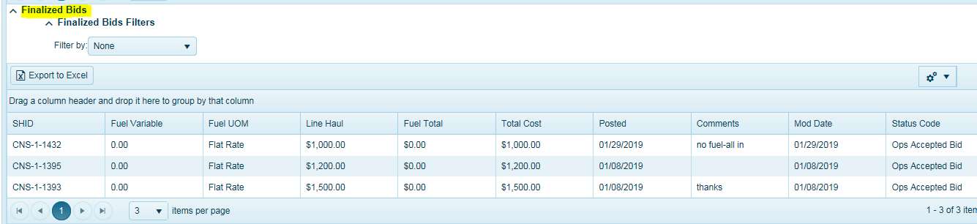

Appointment Scheduling- Carrier Automation

Carriers will only have access to this page if the self-appointed automated scheduling system has been configured. Carriers will have access to appoint both pickup and delivery appointments for loads that have been assigned to them. Using your normal login credentials, carriers can click on Carrier or Carrier Grouped under Appointment Scheduling to see all orders/loads ready to appoint.
Carrier – Will display a single order associated with a ShipID (CNS Number)
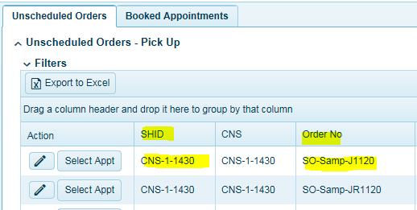
Carrier Grouped -expand the black arrow to display all orders linked to the same ShipID. An example would be a multi stop shipment with many orders that have the same ShipID.
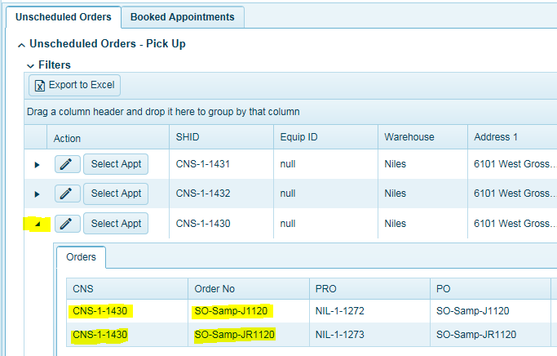

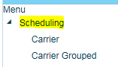
The pending orders summary chart will display orders that are ready to appoint within a 72-hour window (Time window based on user configuration). Carriers can appoint orders/loads as soon as the load is available under the Unscheduled Orders – Pick Up tab.
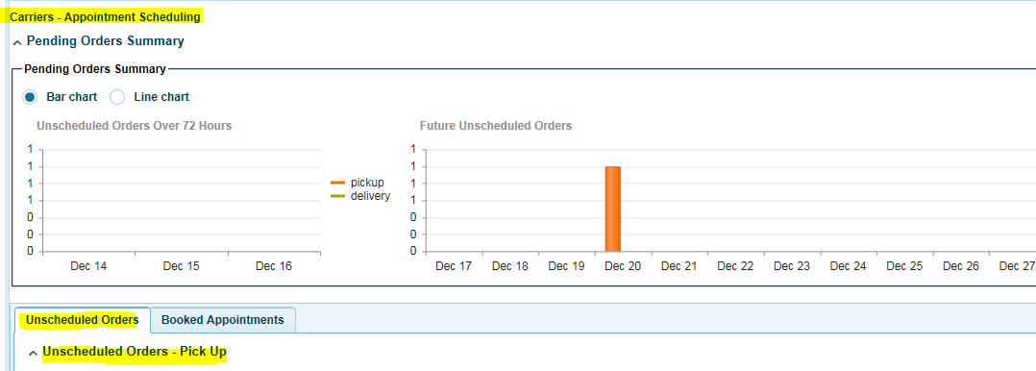
To schedule an appointment, click on the Unscheduled Orders tab.
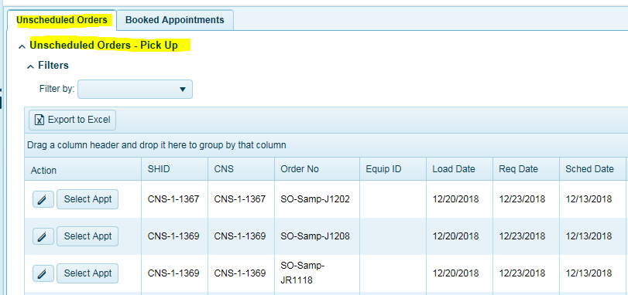
Here you will see a list of the orders/loads that have been assigned to you and waiting to be appointed.
Grouping- Users can group the data by CNS or ShipID by clicking on the label and dragging the column up and releasing in the block. This will group all orders assigned to the same CNS or ShipID for easier viewing. In other words, the same load.
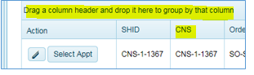
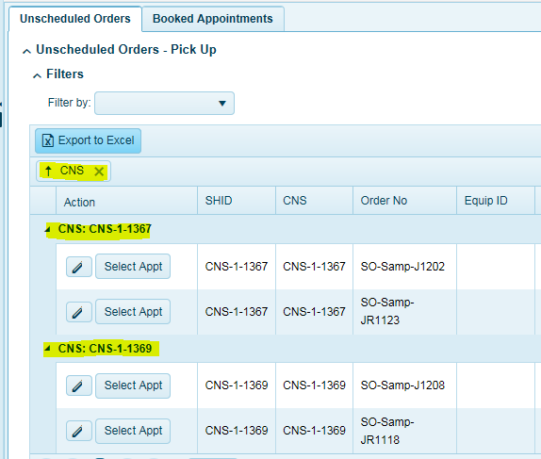

To make an appointment, click on Book Appt. A dialog box will open displaying the warehouse location and times available to select. Use the scroll forward to find additional time slots. Carriers should always use a time in the future when making appointments.
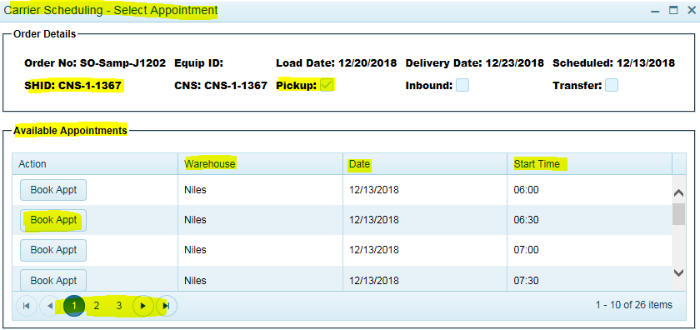
Book Appt = Select to confirm this time slot.
Warehouse = Location where the load is to be picked up.
Date = Appointment load date
Start Time = Appointment time.
Use the arrow to page through available time slots.
An email confirmation will be sent to the carrier scheduler email address that was configured.

If you have multiple orders to be appointed and want to assign them to the same Appointment Id and time, use the Equipment ID to apply to multiple orders.
Click on the pencil icon, the Equip ID field will open. Enter in a unique identifier that will link multiple orders to the same appointment. For example, could be a trailer number, carrier number etc. Apply this identifier/number to all orders in order to have the same pick up appointment applied.
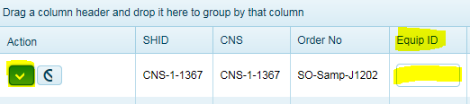
click on Select Appt. A dialog box will open displaying the warehouse location and times available to select. Use the scroll forward to find additional time slots.
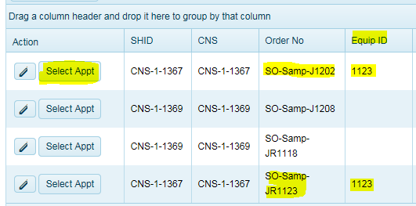
To see appointments that have already been booked-click on Booked Appointments.
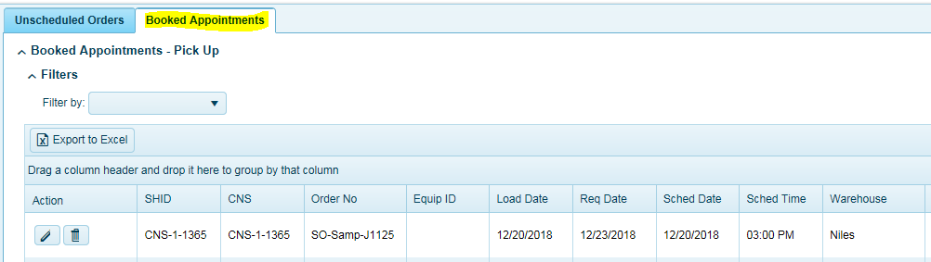
To edit or delete an appointment, click on the Pencil icon to edit or Click on the Delete to delete the appointment. Depending on the system configuration, shippers may allow carriers to edit/delete or they will have to make a request via the system to edit/delete an appointment. 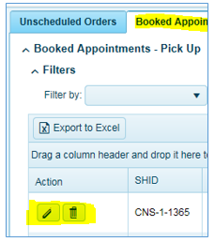
Carriers may not be allowed to change an appointment if the request is within a certain time frame prior to loading based on shipper’s configuration.

